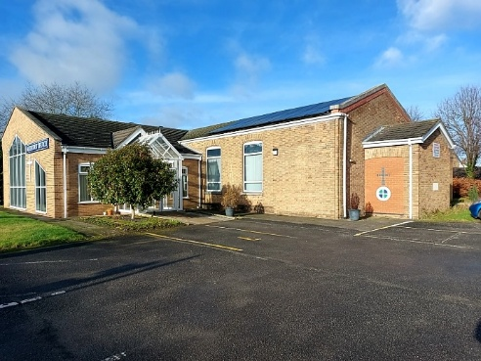
BRIGG METHODIST CHURCH
Wesley Road, Brigg, DN20 8TR
Contacts:- Superintendent Minister- Revd. Robert Roberts 07395 453246
or Lay Pastoral Worker-Mr. Richard Atkinson 07907 001174
NOTICES FOR OCTOBER 2026
In October 2026, our morning worship at 10.30am will be led by:-
Oct 4 Mrs Jane Sheard. This is our Harvest Festival celebration
Oct 11 Rev John Schofield
Oct 18 Rev Robert Roberts Holy Communion
Oct 25 Mrs Bev Barker-Lawrence
All our morning worships are on Zoom. The ID code is 978 8891 8428
Do stay after the service for coffee, tea etc
And, at 6pm on the 11th, on Zoom, WOZ- Worship on Zoom. (Same ID code as above)
The Food and Faith at Five worship at St. John’s Church Hall will be on Oct 4th at 5pm.

At the recent District Synod, the proposal to re-shape our District into One Circuit was accepted by a majority. More consultations will take place before taking the proposal to Conference next Summer.

Our regular weekly clubs, groups and fellowships held at the church, or at Oikos are:-
Day Time Activity Venue
Monday 13.00 Bible Group Oikos
15.00 Drop-In Youth Group Church
Tuesday 9.15 Prayers Oikos
18.00 Bev’s Word, Walk and Witness group
Wednesday 16.00 Let’s Chat Youth Group Church
Thursday 10.00 Coffee and Warm Space Church
11.00 Prayer Meeting (in the prayer room)
15.00 Gardening Group Church
17.00 Kid’s Activity Group Church
18.30 TBD Youth Group Church
Friday 15.00 3 O’clock Club Church
18.30 Youth Club Church
The Wednesday Group meet fortnightly at 13.45 at the church. This month they meet on October 7th and 21st
A Café Fellowship is held every 2nd and 4th Tuesday at 10am at Oikos.
In September, it will be on the 8th and the 22nd
NB. Please check the bookings sheet for October on the notice board in the entrance hall for any changes.
Brigg Methodist Church
Saturday 3rd October at 7pm
Harvest Quiz Night and Pizza and Apple Pie Supper
Tickets. £7.50 from Mary, Jackie, or Pat
Sunday October 4th at 10.30am.
Harvest Festival Worship led by Mrs Jane Sheard

DATES FOR YOUR DIARY

Sunday October 4th at 10.30 am. Harvest Festival Service at Brigg
Saturday October 11th at Broughton, Quiz Night with Pie and Pea Supper.
Sunday 11 October at 10.30 at Barrow. Big Assembly Sing-along.
Wednesday October 14th at 2pm. Brigg Church Council Meeting

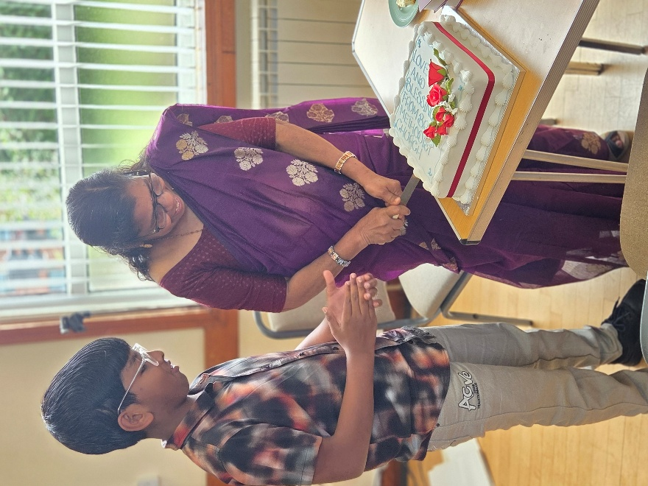
On Sunday 13 September, we said “Goodbye” to Lurdammal Lurthammal, better known to us as “Amin’s Grandma”.
Lurdammal’s visa has expired and she has to return to India after 2 and a half years living in Brigg.
She has become a great friend to all of us at Brigg. Despite speaking hardly any English, she came every Sunday, accompanied by her grandson, who translated everything for her. Her colourful saris were the talking point of all the ladies.
In the service, which was a café church style of worship, Lurdammal cut a celebration cake, which was shared by everyone and the final slide on the PowerPoint presentation was a good luck, we will miss you and God bless you message in her own language, Malayalam .

Great News!!!!
Following our Community/Eco Garden being awarded a Highly Commended certificate by Brigg Town Council, we then had the news that we have also been awarded a cash prize by the CPRE (Campaign for the Protection of Rural England). Next year Chelsea Flower Show award???!!!

Your Church- How can you help?

At a recent Café Church, we learned how much it will cost in the next church year to keep our church building open. It is a staggering £46,000 !!!
Are you able to give a bit more each week, financially? Just £1 a week more from all members and friends would raise over £2,500 each year. Can you Gift Aid your giving?
Are you able to help out more? Go on the coffee rota on a Sunday or a Thursday morning? Keep the place tidy and clean? Take home the tea towels/ tablecloths to wash? Provide tea, coffee, biscuits etc? Give Malcolm and Amin some help occasionally on the IT? Become a church steward? Help in the garden? Give someone a lift in your car?
All of these jobs are done, mostly, by a small group of members, who work their socks off. Can you help them out?

